**AREAS OF EXPERTISE**

*Networking – Switches /*

*Routers / Firewalls*

*Diagnosing hardware &*

*software faults*

*Training & Development*

*Infrastructure support*

*Server support*

*Microsoft technologies*

*Data Protection*

*Remote support tools*

**PROFESSIONAL**

*Practical fire protection*

*in computer* rooms and data centers

*Symantec Backup Exec 2010*

*for Windows Administration*

**PERSONAL SKILLS**

*Problem solving*

*Customer service skills*

*Troubleshooting*

**PERSONAL DETAILS**

*Saidi Akram*

*DOB: 08/08/1987*

*Nationality: Tunisian*

*Addres:* *Dynayskiy Prospekt, 35,*

*Kop 3, kv 16 Saint Petersburg*

*Russie 192281*

*Driving license: Yes*

*T: +7965093 79 93*

*E:*[*saidiakrem@yahoo.fr*](mailto:saidiakrem@yahoo.fr)

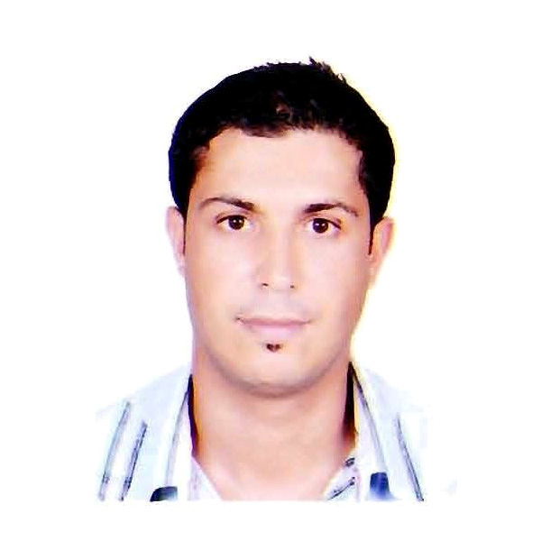

Saidi Akram

# Systems and Networks Engineer

**PERSONAL SUMMARY**

Polyvalent IT Engineer, My experience covers multiple technologies and solutions, extensive experience of working in the helping clients and colleagues resolve complex technical IT issues. Possessing excellent client facing skills, natural problem solving and analytical skills and able to contribute to the development of best practice, procedures and policies within a company.

Currently looking for a suitable **Full Stack Developer** position with an ambitious company

or organization.

**WORK EXPERIENCE:**

***Tanagold International transportation services – Saint-Petersburg***_***Russia***

**Systems and Networks Engineer January 2015 - Present**

Responsible for supporting the company clients at all levels as part of a helpdesk team.

Ensuring that all hardware and software is configured and installed correctly.

***Duties:***

* Responsible for diagnosing & resolving hardware, software & end users problems.
* Acting as the first point of contact for all IT & technical queries.
* Developing the infrastructure and systems to meet the company’s needs.
* Working within a TCP/IP network environment, including DHCP, DNS and Ethernet
* Involved in the rollout of software updates and patches.
* Investigate specialist and complex IT support issues.
* Configuring and managing backup & restore procedures.
* Maintaining a wide range of computer hardware and software programmes.
* Identifying & reporting on the budgetary implications of IT projects and upgrades.
* Provide secondary support for LAN administration.
* Responsible for allocating work to junior staff and induction training for new staff.
* Deploying new hardware, server backups & evaluating new software & security risks...

***Studi International – Tunisia***

**Junior System and Network Administrator January 2011 - November2014**

Reporting directly to the IT Manager and collaborating closely with other IT team members.

Responding to queries in a timely and accurate manner and resolving queries to the user’s

satisfaction

***Duties:***

* Responsible for networking, design, installation and maintenance services.
* Supporting users and network administrators over the telephone and by email.
* Applying patches in accordance with company procedures.
* Networking and providing support for Windows, Macintosh and Linux issues.
* Configuration and testing of any new hardware and software.
* Travelling to client sites to help with installs, deployment, and troubleshooting.
* Management of the daily data backup and retrieval scheme.
* Installing and operating Windows desktop and server operating systems.
* Assisting the network manager with support requests.
* Training new employees.

**Languages:**

French (Read Write Speak)

English (Read Write Speak)

Russia (Read Write Speak)

Arabic (Native language)

***SevenTech – Tunisia***

[**Computer technician**](http://www.prospects.ac.uk/it_technical_support_officer_job_description.htm) **February 2010 - July2010**

***Duties:***

* Install, repair and support computers based on Windows 7 and Windows 8.
* Install Windows based applications, such as Microsoft Office.
* Install, troubleshoot and support Email Clients, such as Outlook
* Maintain an inventory of electronics components needed to make timely repairs.
* Use the help desk system to document, track and resolve incoming customer requests (tickets) to customer satisfaction
* Refer complex problems to Upper-level technical support.
* Read and interpret network diagrams, software documentation and hardware documentation to provide required technical support
* Install and support patch management systems
* Install and support network monitoring systems
* Install and support anti-virus/anti-spam systems
* Install and support backup systems
* Maintain functionality of customer email, internet, and windows domain systems

**Managerial Skills:**

* Physically fit & able to lift IT equipment, crawl under desks to access cabling etc.
* Experience of problem resolution & quality assurance procedures.
* Able to communicate complex IT issues to suppliers and non-technical staff.
* Ability to work well in a team environment.
* IT security experience including anti-virus / malware, encryption deployment.
* Experience of web content management systems.

**Technical Skills:**

* **Systems :** GNU/Linux (Debian, Ubuntu), Windows Server 2003/2008/2012, Windows Systems, Mac OS X
* **Networks :** LAN, WLAN, Routage IP, NAT, VLAN, Firewall, Proxy
* **Protocols:** DNS, SSH, FTP, CIFS, DHCP, HTTP(S) SNMP.
* **Tools :** Active Directory, GPO, WSUS, McAfee ePolicy, SYMENTEC BACKUP EXEC 2010, Norton Ghost, Images WIM, VPN Cisco…
* **Analyse :** Merise, UML
* **Software :** Suite Microsoft Office, Thunderbird, Wireshark, VMware ESXi, vCenter, vSphere, Hyper-V…

**ACADEMIC QUALIFICATIONS:**

* **2011 – 2014: Computer Engineering**

Arab University of sciences – Tunis Tunisia

Specialty: Networks and Information Systems

* **2012 :** **Training Symantec Backup Exec 2010 for Windows Administration**

Advancia-training

* **2007 – 2010: Applied license in computer networks**

Higher Institute of Computer and Communication Techniques - Hammam sousse Tunisia

Specialty: Computer Networks and Telecommunications

* **2004 – 2007: Technical bachelor**

Technical high school 9 April 1938 – Sidi Bouzid Tunisia

**(*REFERENCES – Available on request*)**